# **AoW—Hajj Selfies Name:**

|  |
| --- |
| Directions:  𑂂 Annotate the article strategically (that means developing thoughts that you’d be interested in expanding upon in the written reflection).  𑂂 Complete the Reading for Meaning Statements  𑂂 Write a **well-developed** response to the article--on your own sheet of paper. You may choose one of the questions to respond to or choose a question or ideas of your own.  **Guidelines:**   * Clever title properly capitalized. * Summarizes some of the articles main points and arguments **and** responds with questions, opinions, and arguments of your own. * Appropriately leads into, blends, **parenthetically cites**, and discusses **at least** one quote or key fact / statistic from the article. * Explain each quote and discuss your reaction to it (agree or disagree). * Concluding sentences. * 250+ words, NEAT, LEGIBLE, NO DISTRACTING ERRORS. |

**How Will This Be Graded?**

|  |  |
| --- | --- |
| **Reading** | **Writing** |
| |  |  |  | | --- | --- | --- | | **4-5** Strong effort. Mature thinking is obvious. The student makes several margin notes, showing thoughtful interaction with the text. The student circles and defines unknown or challenging words. Margin notes show that the reader is asking questions, identifying main ideas, and connecting to the focus question. Reading for Meaning statements are supported or refuted with relevant evidence. | **3** Adequate effort. The student interacts with the text, but may struggle to dig deep. The student may circle and define unknown or challenging words. Margin notes show that the reader is using some reading strategies to improve comprehension. Reading for Meaning statements are attempted. | **2** Some effort. Interaction with the text is basic. Margin notes are there but do not demonstrate that the reader is thinking deeply about the text. Reading for Meaning statements are not all completed.  **0-1** Little to no effort displayed. Margin notes may not even be there. Reading for Meaning statements are not attempted. | | |  |  |  | | --- | --- | --- | | **5** Outstanding effort. The student obviously proofed this paragraph, focusing on neatness and accuracy. Exceeds all requirements. | **4** Good effort. The product is neat and legible. Meets all requirements.  **3** Adequate effort. The product is legible. Meets most requirements. | **2** Weak effort. The student only completed some of the task.  **0-1** The student completed little to none of the task. |   **Total AoW Grade:**  **______/10** |

**Reading for Meaning Statements**

**Directions:** The purpose of this page is to hone your ability to gather textual evidence to support or refute a statement **and** to focus your reading on some key points in the article. For each statement below, circle whether the text agrees or disagrees with it, and, in the space provided, share quoted, textual evidence to support your agreement or disagreement.

|  |  |  |
| --- | --- | --- |
| **Agree?** | **Statements** | **Your Evidence (cite page and paragraph; briefly explain)** |
| |  | | --- | | **yes** | | **no** | | 1. The Hajj selfies have generated a lot of controversy. |  |
| |  | | --- | | **yes** | | **no** | | 2. All psychologists agree that the taking of selfies is a negative behavior. |  |
| |  | | --- | | **yes** | | **no** | | 3. Only the religious leaders and scholars are bothered by Hajj pilgrims taking selfies. |  |

# Infamous Hajj Selfie Is One More Thing Transforming Mecca, And Not Everyone Is Happy About It

**The Huffington Post  | By**[**Antonia Blumberg**](http://www.huffingtonpost.com/antonia-blumberg/)Posted: 10/01/2014 3:28 pm EDT

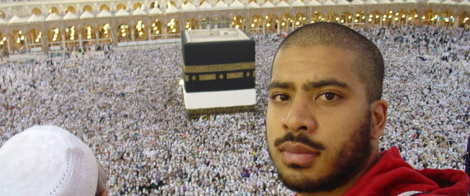

The infamous selfie is becoming a fixture in modern life, and we need look no further than this year's hajj to see why.

Millions of Muslim pilgrims will make the[journey to Mecca for hajj](http://www.huffingtonpost.com/2014/09/26/hajj-2014_n_5889806.html) between October 1-6 this year. They will perform a [series of complex rituals](http://www.huffingtonpost.com/2014/09/28/hajj-rites-explained_n_5889232.html) that include circling the sacred Kaaba and walking seven times between the hills of Safa and Marwa -- and many will whip out their phones now and then to snap a photo.

Mecca visitors have plenty of other things to worry about, from [gentrification](http://www.huffingtonpost.com/2014/10/01/saudis-mecca-_n_5913034.html?utm_hp_ref=religion) to [terror threats](http://www.huffingtonpost.com/2014/09/30/isis-hajj-mecca_n_5908398.html?utm_hp_ref=religion), but for some the selfie is another dreaded intrusion on the holy site. Arab News recently wrote about the [pushback among scholars and other pilgrims](http://www.arabnews.com/islam-perspective/news/637771) who call the practice "touristy behavior" and "humble-bragging."

Scholar Sheikh Assim Al-Hakeem, based in Jeddah, argued that selfies go against the spirit of Hajj:

“Photography without a legitimate reason is an issue of dispute among scholars. However, despite this difference of opinion, there shouldn’t be any dispute when it comes to the real meaning of Hajj and the essence behind it. It is based on sincerity and following the sunnah. The Prophet (peace be upon him) when he went for Hajj, he said: 'O Allah, I ask of you a pilgrimage that contains no boasting or showing off.' Taking such selfies and videos defy the wish of our Prophet.”

Al-Hakeen may have a point. Research psychologist Peggy Drexler argued in a 2013 Psychology Today article that [selfies may signal narcissism](http://www.psychologytoday.com/blog/our-gender-ourselves/201309/what-your-selfies-say-about-you).  
  
"There’s a sense that selfie subjects feel as though they’re starring in their own reality shows, with an inflated sense of self," Drexler wrote.

A more recent Psychology Today article from Pamela Rutledge, the Director of the Media Psychology Research Center at Fielding Graduate University, takes a different approach. Selfies, she said, are [casual and unmediated](http://www.psychologytoday.com/blog/positively-media/201407/the-psychology-the-selfie), allowing people far and wide to feel that they are a part of something even if they aren't there.

"By and large, selfies are a product of the exuberance of the moment and allow communication directly from the individual on the scene," Rutledge wrote.

Beyond the high-profile selfies, we also get to vicariously experience the World Cup, concerts, and other high-profile gatherings through the visual exuberance of millions of "regular people" from around the world, rather than having our window onto the event curated by the aesthetics and storytelling of professional photographers. Granted, the pros' shots are usually higher quality, but selfies are about "being there"—with another person. How many times have you wished you could share a moment with someone far away? Now you can, in a heartbeat.

Mecca is [off-limits for non-Muslims](http://islam.about.com/od/hajj/f/mecca.htm), so for them and any Muslims unable to make the trip for economic or health reasons, photographs offer a glimpse inside an otherwise unknown territory. There is even a [3D app available](http://www.huffingtonpost.com/2014/06/09/mecca-app-virtual-hajj-_n_5473624.html) for those interested in going on a "virtual hajj."

Another argument from selfie-critics is that incessant photo-snapping interrupts the moment and can cause undue commotion -- especially with [two million people](http://www.cnn.com/2013/06/21/world/hajj-fast-facts/) trying to make their way through the hajj rites.

"I was trying to pray Jumma in Masjid Al-Haram but a few people kept coming in front of me to film the Khutba (sermon) with their cameras," a pilgrim [told Arab News](http://www.arabnews.com/islam-perspective/news/637771). "What happens to one’s khushoo (serenity in prayer) in such a situation is anyone’s guess."

Mecca [has changed dramatically](http://www.huffingtonpost.com/2014/09/08/mecca-transformation-photos_n_5738098.html) over the last century, and perhaps the selfie is just one more 21st century embellishment to the ancient site, for better or worse.

Take a look at a sampling of hajj selfies below and let us know what you think: inappropriate or harmless fun?

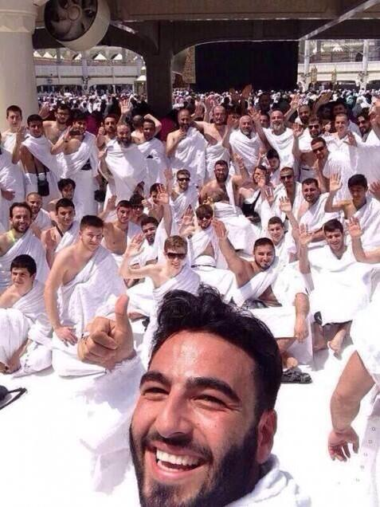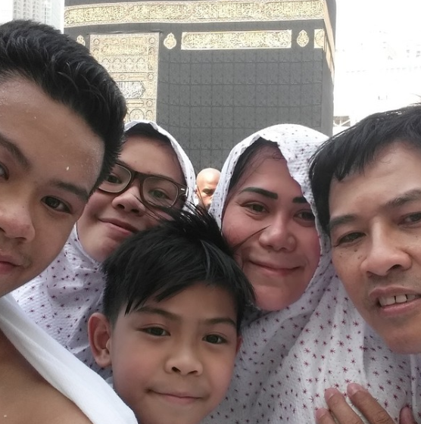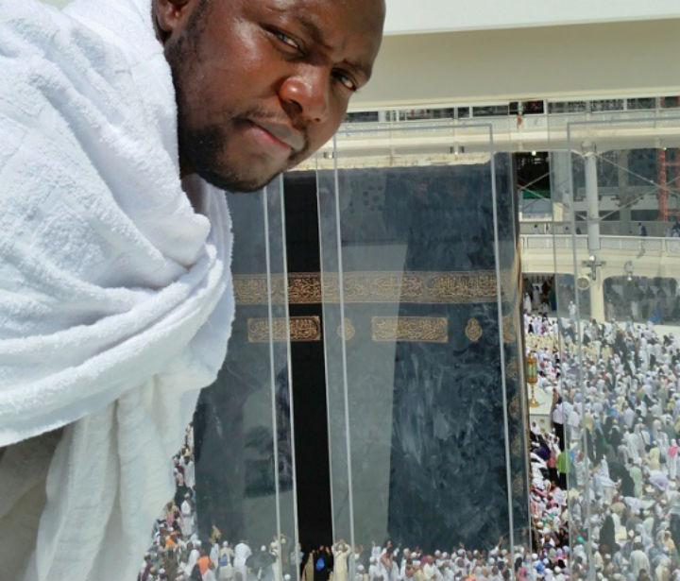

See more at <http://tinyurl.com/hajj-article> (or search with the title of the article)

**Guiding questions for summary of expository article**.

* **What is the main subject of this article?**
* **Explain the subject a little (Who, what, when, where, and or why)**
* **Are there any opinions expressed in this article? If so…**
  + **Who gives their opinion?**
  + **What is their opinion on the subject?**
  + **What reasons or evidence do they have to support their opinion?**
* **Include at least one piece of evidence and explain what it means and why it is important.**
* **Does this article have a purpose beyond just explaining? Is it trying to convince you to change your mind? Change your behavior? Vote a certain way? Other?**
* **Concluding statement**

# ……………………………………………………………………………………………………

**Possible questions for written response (choose one of these or one of your own)**

* **Respond to the question at the end of the article. Be sure to explain and justify your opinion.**
* **When, if ever, are selfies inappropriate and why?**
* **Other questions, observations, or arguments you have related to this piece**